

2023 Japan Study Trip (Autumn Tour)

UAE-Japan Cultural Center will hold 4th “Japan Study Tour” in November 2023.
The tour is very popular among our students, as it is a trustworthy, reasonable and meaningful trip offered especially to our students.
Previously 3 Japan Study Tours were held in 2015, 2017 and 2019.
In summer 2015, we visit the most famous & attractive places in Osaka / Kyoto / Nagoya / Fuji Mountain / Tokyo.
In summer 2017, more featured on historical visits in Osaka / Kyoto / Hiroshima / Nara / Fuji Mountain / Tokyo.
In Spring 2019, “Sakura Tour” with special purpose to see Sakura (Cherry blossom), visiting Tokyo / Kanazawa / Osaka / Kyoto.

New trip in 2023, we plan to visit Eastern part of Japan, where many beautiful places in the nature charm the tourists in Autumn. All the destinations are carefully selected. This time, we modify the style of tour, and the participants will enjoy more workshops, activities and free time.

Japan Center’s students have priority to participate, who understand the purpose and objective of the Center. You can invite your family and friends as well.
If we have 20 people initially to join, we will hold the tour in November. (If we have more participants, the fee will be lower. The initial fee is estimated with 20 participants.)

Period | November 10 to 18th  (8 days/ 8 night) | It could be a week before or after, according to the weather in Japan. The exact dates will be announced in July upon Japan Meteorological Agency announce the Autumn forecast.
Place to visit | Osaka, Kyoto, Central Japan (Shimane, Tottori, Himeji, Okayama), Tokyo
Estimated Fee (without flight ticket) | around AED 14,000~16,000

The fee includes: All transportation with domestic flight, bus & Shinkansen, 8 breakfast, 8 lunch, some dinner (all Halal foods), Entrance Fee, Workshop Fee, Japanese tour coordinator, 2 Teachers and 4 star-accommodations.
The installment of the fee will be twice. First, the participants will pay the half amount of the trip in July. Then they will pay the rest (full amount will be adjusted with number of participants) in October. The more number of participants, the lower the fee will be. Whoever wants to take single room, will pay a little higher than shared room users.
Places to visit
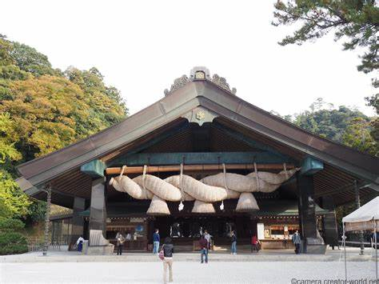

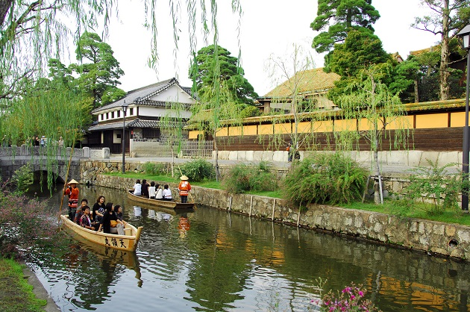

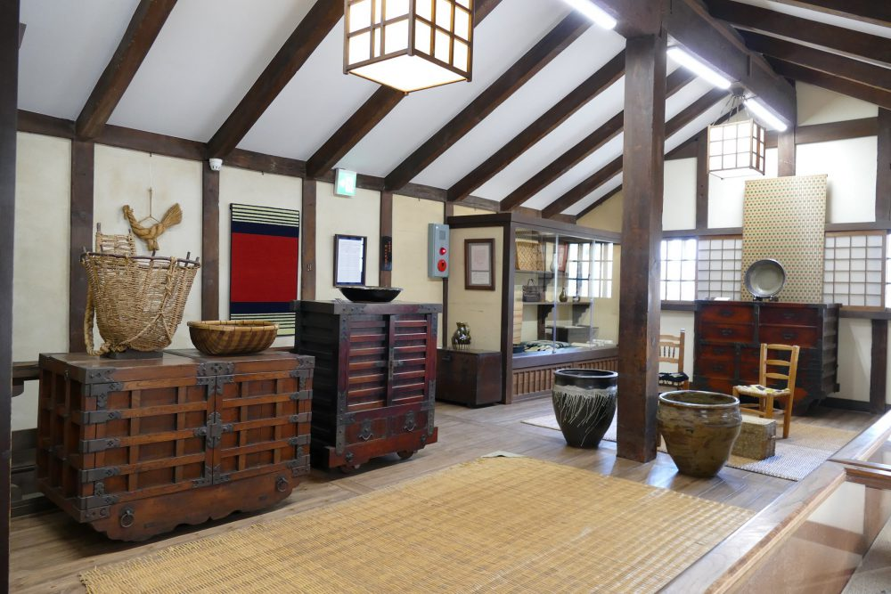

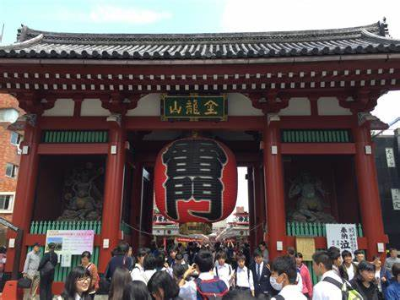

Hiking course in nature
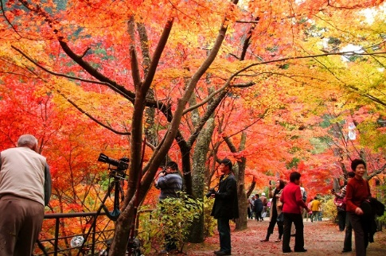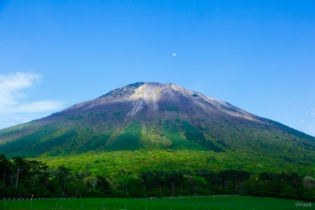

Workshops
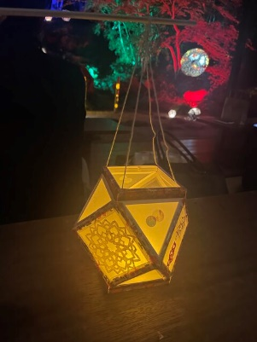

Example Foods (breakfast and lunch) : Arabic and Indian Food will be served once a day


Orientation Day : June 17th at Art For All Center, Sharjah
Application Deadline : June 30th, 2023
First Payment : End of July
Second Payment : Middle of October

2023, 4,30

